**East West University**

**Department of Computer Science and Engineering**

Coues instructor**: DR. Ahmed Wasif Reza**

**CSE 107: Object Oriented Programming**

**Summer 2018**

**Section: 3**

**Project**

**GROUP 6**

**MEMBERS:**

**Name:Abdur Rahman Tumzied**

**Id:2018-1-60-076**

**Name: Hasibul Islam**

**Id:2018-1-60-112**

**Name: Imam Hossain Sajeeb**

**Id: 2018-1-60-173**

**Target:**

Our target was to make a simple 2d game with the help of **SFML**. Our game main concept is there will be 2player, both of them can move up, down, left and right. And both of them can shoot projectile (fire ball). Both players have 30hp at the start of the game. There is a heal item that spawn randomly after 20 second if a player touch it he get +5hp but hp wound not go more then 30. And some of the obstacles that we put one is a fire ball wall , if player came close to it he will loss 2hp and if projectile hit those fire walls projectile will get erase. And fire wall change its position after every 10 second . Now both of the players shoot each other at last one of them player hp hit 0. Both player have attack damage is 1. So, if projectile collide with players they will lose 1hp every time a projectile collide.

[To run this game we need visual studio 2017]

In our project files ConsoleApp2.cpp is the main file that connected all other header files.

For our first player / player1 is correspond to player.h and player.cpp and for 2nd player enemy.h and enemy.cpp is correspond

**SYSTEM DESIGN:**

**item**

**Projectile**

**player**

**anotherE**

**Enemy**

**ConsoleApp2**

**class : Player ( first player class )**

There are some data member those are: speed, hp, max hp, attack damage etc.

And some member function those are

void update_position();

this member function update the current position of the player and set up with a new position base on user inpute.

void updatemovement();

this member function take user input and moved base on I t

1st player input are :

* Up arrow to go up
* Down arrow to go down
* left arrow to go left
* Right arrow to go right

**class**: **Enemy ( 2nd Player class)** is almost the same as 1st player class but user input are little bet different

Those are :

* W to go up
* S to go down
* A to go left
* D to go right

**class :Projectile**

Projectile class have a data member that call (sf::CircleShape shape1) its represent shape of circle and Radius is (7.5) and a member function call void movement () , this function is move the projectile base on which direction player are facing .

If players

* facing left projectile move left
* facing right projectile move right
* facing up projectile move up
* facing down projectile move down

If users press” space bar” for 2nd player and number_pad “ 0 “ for 1st player , both of the player will soot projectile .

**class : AnotherE**

class have a data member that call (sf:: RectangleShape shape) its represent shape of Rectangle , other data member (sf::Texture tex) this data member **tex** load a image from file , tex.loadFromFile("flame.png") . Data function **positionUP** , this function randomly changes the object position after every 10 second .

code =>

void anotherE::positionUP()

{

time1 = clock1.getElapsedTime();

if (time1.asSeconds() > 10.0) {

shape.setPosition(sf::Vector2f( 300 + rand()% 350, 30 + rand() % 700 * 1.0f));

clock1.restart();

}

}

**class : AnotherE**

class have a data member that call (sf:: RectangleShape rect) its represent shape of Rectangle other data member (sf::Texture img) this data member **img** load a image from file img.loadFromFile("apple.png"). Data function **void reandomplace()** spawn object randomly after 20 second.

Code=>

void reandomplace()

{

time1 = clock1.getElapsedTime();

if (time1.asSeconds() > 20.0) {

rect.setPosition(sf::Vector2f(300 + rand() % 350, 30 + rand() % 700 * 1.0f));

time1 = clock1.restart();

}

}

**Output:**

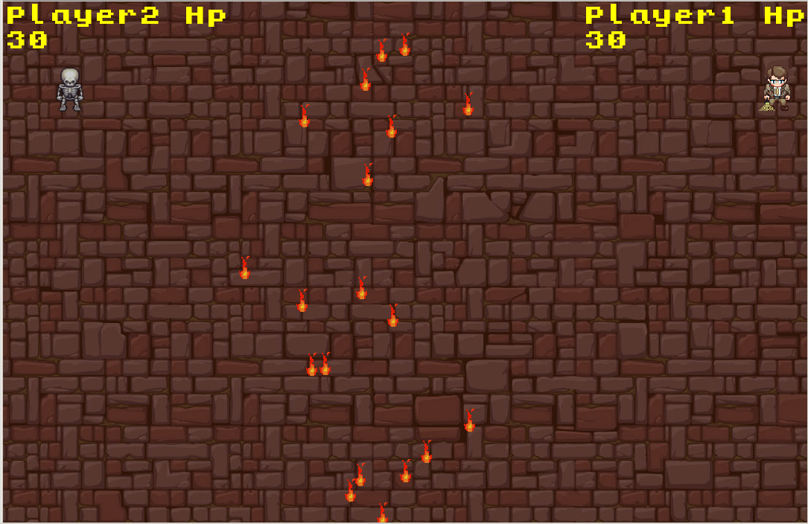

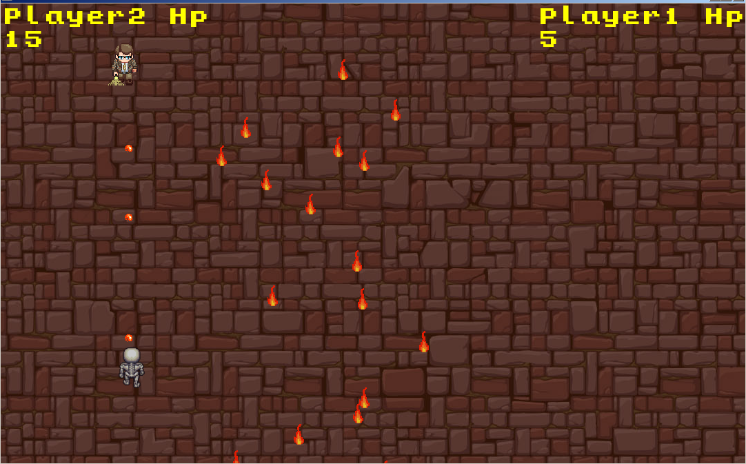

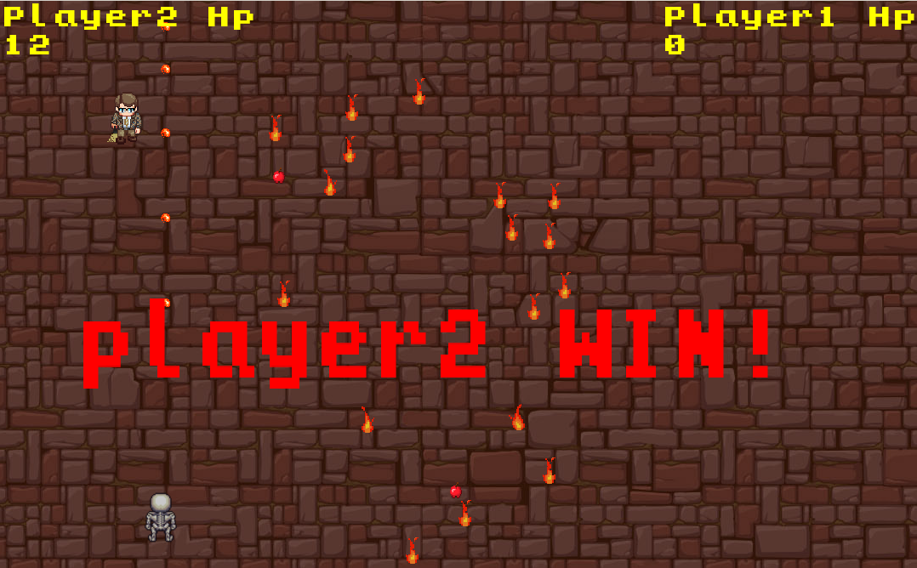

**LIMITATIONS OF YOUR PROGRAM:**

Brief limit the frame rate to a fixed frequency, in this project we set frame rate limit to 60 fps

|  |  |
| --- | --- |
| **Student ID** | 2018-1-60-076 |
| **Name** | **Abdur Rahman Tumzied** |
| **Session** |  |
| **Project No.** |  |
| **Date submitted** |  |
| **Deadline of the project** |  |
| **My contribution in doing this project (in percentage) in the group** |  |
| **Number of hours I spent in doing this project** |  |

|  |  |
| --- | --- |
| **Student ID** | 2018-1-60-112 |
| **Name** | **Hasibul Islam** |
| **Session** |  |
| **Project No.** |  |
| **Date submitted** |  |
| **Deadline of the project** |  |
| **My contribution in doing this project (in percentage) in the group** |  |
| **Number of hours I spent in doing this project** |  |

|  |  |
| --- | --- |
| **Student ID** | 2018-1-60-173 |
| **Name** | **Imam Hossain Sajeeb** |
| **Session** |  |
| **Project No.** |  |
| **Date submitted** |  |
| **Deadline of the project** |  |
| **My contribution in doing this project (in percentage) in the group** |  |
| **Number of hours I spent in doing this project** |  |

**We hereby certify that this project represents the work done by all our group members with our contribution clearly. We declare that no part of our work has been copied from or by other groups, and that no collusion has taken place with any other persons or groups. We certify that any disks submitted with this project have been virus checked and have no viruses on them.**

(1) Signature: …………………………… Date: ........................................

(2) Signature: …………………………… Date: ........................................

(3) Signature: …………………………… Date: ........................................